

**AP®  Computer Science A**

**2014 Free-Response Questions**

© 2014 The College Board. College Board, Advanced Placement Program, AP, AP Central, and the acorn logo are registered trademarks of the College Board.

Visit the College Board on the Web: www.collegeboard.org.

AP Central is the official online home for the AP Program: apcentral.collegeboard.org.

**Directions: SHOW ALL YOUR WORK. REMEMBER THAT PROGRAM SEGMENTS ARE TO BE WRITTEN IN JAVA.**

Notes:

* Assume that the classes listed in the appendices have been imported where appropriate.
* Unless otherwise noted in the question, assume that parameters in method calls are not null and that methods are called only when their preconditions are satisfied.
* In writing solutions for each question, you may use any of the accessible methods that are listed in classes defined in that question. Writing significant amounts of code that can be replaced by a call to one of these methods may not receive full credit.

4. The menu at a lunch counter includes a variety of sandwiches, salads, and drinks. The menu also allows a customer to create a "trio," which consists of three menu items: a sandwich, a salad, and a drink. The price

of the trio is the sum of the two highest-priced menu items in the trio; one item with the lowest price is free.

Each menu item has a name and a price. The four types of menu items are represented by the four classes

Sandwich, Salad, Drink, and Trio. All four classes implement the following MenuItem interface.

public interface MenuItem

{

/** @return the name of the menu item */ String getName();

/** @return the price of the menu item */ double getPrice();

}

The following diagram shows the relationship between the MenuItem interface and the Sandwich, Salad, Drink, and Trio classes.

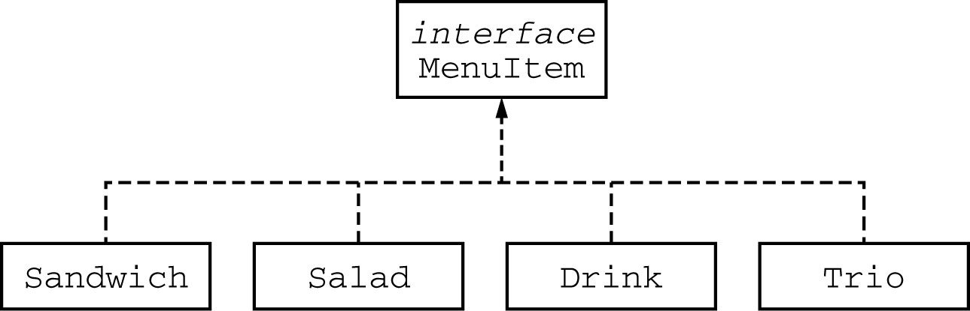

For example, assume that the menu includes the following items. The objects listed under each heading are instances of the class indicated by the heading.

Sandwich Salad Drink

|  |  |  |  |  |
| --- | --- | --- | --- | --- |
| "Cheeseburger" |  | "Spinach Salad" |  | "Orange Soda" |
| 2.75 |  | 1.25 |  | 1.25 |
| "Club Sandwich" |  | "Coleslaw" |  | "Cappuccino" |
| 2.75 |  | 1.25 |  | 3.50 |

Question 4 continues on page 13.

The menu allows customers to create Trio menu items, each of which includes a sandwich, a salad, and a drink. The name of the Trio consists of the names of the sandwich, salad, and drink, in that order, each separated by "/" and followed by a space and then "Trio". The price of the Trio is the sum of the two highest-priced items in the Trio; one item with the lowest price is free.

A trio consisting of a cheeseburger, spinach salad, and an orange soda would have the name

"Cheeseburger/Spinach Salad/Orange Soda Trio" and a price of $4.00 (the two highest prices are $2.75 and $1.25). Similarly, a trio consisting of a club sandwich, coleslaw, and a cappuccino would have the name "Club Sandwich/Coleslaw/Cappuccino Trio" and a price of $6.25 (the two highest prices are $2.75 and $3.50).

Write the Trio class that implements the MenuItem interface. Your implementation must include a constructor that takes three parameters representing a sandwich, salad, and drink. The following code segment should have the indicated behavior.

Sandwich sandwich;

Salad salad;

Drink drink;

/* *Code that initializes* sandwich, salad, *and* drink *\*/*

Trio trio = new Trio(sandwich, salad, drink); // Compiles without error

Trio trio1 = new Trio(salad, sandwich, drink); // Compile-time error Trio trio2 = new Trio(sandwich, salad, salad); // Compile-time error

**WRITE YOUR SOLUTION ON THE NEXT PAGE.**

Write the complete Trio class below.

**STOP**

**END OF EXAM**